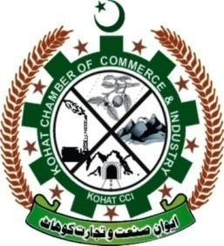

**Kohat Chamber of Commerce & Industry**

**Minutes of Meeting General Body (26-09-2022)**

**Subject: Kohat Chamber of Commerce & Industry announced newly Elected Officials**

General body meeting was held at Kohat Chamber of Commerce and Industry on Monday, 26th September, 2022 at 11:00 AM to elect new president, senior vice president and vice president & Executive Members. The meeting was chaired by the Ex President Syed Faiq Shah.

Meeting formally started with the recitation of Holy Quran. Members of general body participated in the meeting. Elections commission announced newly elected president, senior vice president and executive body unopposed for the year 2022-2023

They also approved the accounts and annual report for the year 2021-2022

The outgoing president Mr.Syed Faiq Shah. addressed the members and expressed his good wishes for the KTCCI.

Mr. Wajid Khan, Secretary General, further added that at this stage of KTCCI we have to increased membership and focusing internal and external matters of the chamber. We taken initiatives for small industry development and improvement of economic zone in Kohat.

All the members unanimously agreed to elect. Arshad Hayat as President, Mr.Kamran Shah as senior vice president and Mr. Ayaz Shah as vice president, unopposed for Kohat Chamber of Commerce & industry.

Newly elected president addressed the General body. He praised outgoing president and executive body for their services. New auditor was appointed in the session namely M/S.Sajjad Hussain & Co. for the year 2022-2023

All members of executive committee congratulate the elected team. The elected members thanked executive committee and pledged to leave no stone unturned for the welfare and progress of business community.

**Secretary General**